A Personal Finance Management System: Insights Through Spending Analytics

Abstract - This study develops a comprehensive Personal Finance Management System designed to analyse users' financial data, predict future expenses, and generate tailored budgeting plans based on their income and spending habits. The system integrates data preprocessing, clustering, and predictive analytics to uncover spending patterns and project next month's expenses using time-series forecasting. Furthermore, personalized budget recommendations are generated to help users optimize their financial management. Leveraging the Kaggle Personal Finance Dataset, the project employs k-means clustering for behaviour analysis, ARIMA and LSTM models for prediction, and visualization tools for presenting actionable insights. The results demonstrate the system's ability to empower users with a deeper understanding of their finances, aiding in achieving financial stability and planning.

Keywords

Personal Finance, Machine Learning, Predictive Analytics, Data Visualization, Financial Behavior

I. INTRODUCTION

Effective personal finance management is a critical skill for ensuring financial well-being, yet many individuals lack the tools to make informed decisions. Beyond categorizing expenses, the ability to predict future spending and develop customized budgets based on income offers a proactive approach to financial planning.
This study introduces a Personal Finance Management System that combines spending analysis, predictive forecasting, and budget generation to empower users in managing their finances.

By analysing transaction data, predicting expenses for the next month, and creating dynamic budgets, the system helps users develop better financial habits. It uses advanced machine learning techniques such as clustering for behaviour segmentation and time-series forecasting models for prediction. Visualization tools ensure the insights are actionable and easily interpretable.
II. RELATED WORK
Several existing applications, such as Mint and YNAB, offer tools for categorizing expenses and tracking budgets but often lack predictive capabilities. Predictive analytics in financial systems has been explored in various domains, particularly in forecasting revenues or market trends, but its application to personal finance is less common. Machine learning methods, such as k-means clustering for user segmentation and ARIMA or LSTM models for time-series forecasting, have shown success in other domains and are adapted in this study to enhance personal finance management.
This project builds upon previous works by combining analysis, prediction, and budgeting in a unified system.

III. Theoretical Basis for Methodology

- Clustering Techniques:
Clustering is a key technique used to group users based on similar spending habits. K-Means clustering, one of the most popular algorithms, works by minimizing intra-cluster variance. Mathematically, the algorithm iteratively adjusts cluster centroids to reduce the sum of squared distances (SSD) from each data point to its assigned cluster center.

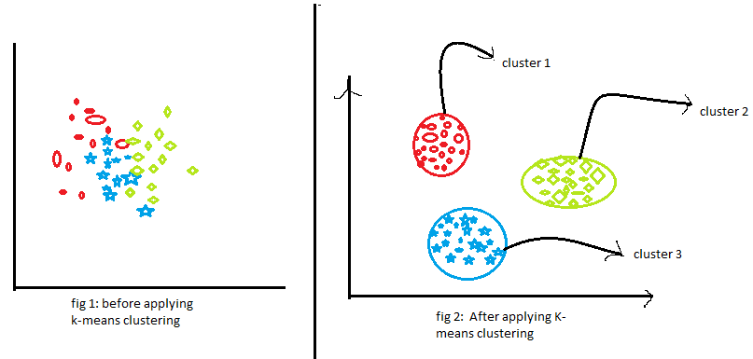

Figure 1: K-Means Clustering

B. Predictive Modeling
Linear regression, a cornerstone of predictive analytics, is employed to forecast expenses. The model assumes a linear relationship between independent variables (e.g., income, profession) and the dependent variable (expenses). The equation y = mx + b forms the basis, where m is the slope, x the independent variable, and b the intercept. Ensuring the validity of regression assumptions, such as normality and homoscedasticity, is critical for accurate predictions.

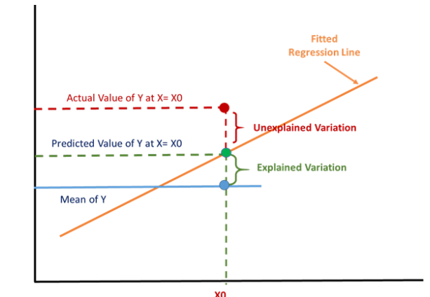

Figure 1: Predictive Modeling using Linear Regression

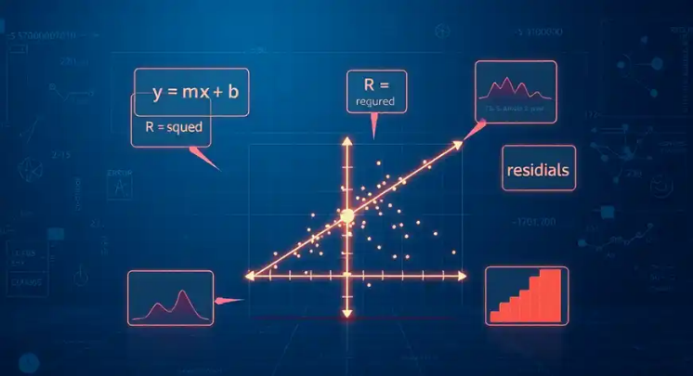

Figure 2: Example of a best fit line in Linear Regression

- Visualization Techniques
Data visualization enhances user engagement by translating analytical findings into intuitive graphics. Tools like pie charts and histograms are used to display categorized expenses, while time-series graphs can illustrate savings trends. The theoretical underpinnings of cognitive load theory emphasize that visual representations reduce the cognitive effort required to process numerical data.
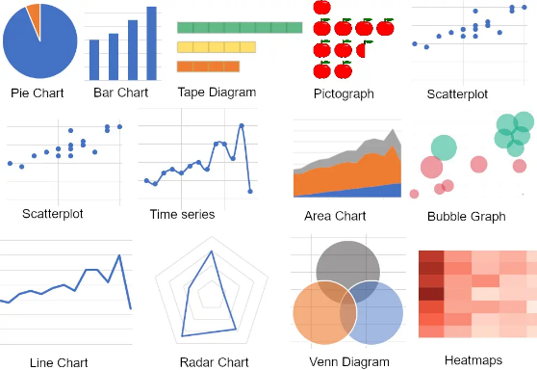

III. DATASET DESCRIPTION
The Personal Finance Dataset from Kaggle is used as the basis for analysis, prediction, and budgeting.
A. Dataset Features
The dataset contains individual transaction records with attributes such as:
- Transaction Details: Date, amount, and description.
- Categories: Food, transport, utilities, entertainment, etc.
- Account Type: Credit, debit, or cash transactions.
- Income Details: Income records are included, allowing for personalized budgeting.
B. Preprocessing Steps
- Handling missing values and removing duplicates.
- Standardizing categorical labels and normalizing transaction amounts.
- Splitting data into training and testing sets for predictive modeling.

IV. METHODOLOGY

A. Data Pipeline
- Data Cleaning and Categorization:
  - Transactions are grouped into categories based on predefined labels or through unsupervised clustering.
  - Income records are separated to calculate disposable income.
- Feature Engineering:
  - Features include transaction frequency, average spending per category, and income-to-expense ratio.
  - Time-series data is aggregated by month for forecasting.

- Clustering for Spending Analysis:

Clustering is used to group spending behaviors:
  - Algorithm: k-means clustering identifies spending patterns.
  - Features: Total spending, frequency of transactions, and category proportions.

- Predictive Analytics
Expense Prediction: Time-series forecasting is used to predict next month's expenses.
• Models: ARIMA (Auto-Regressive Integrated Moving Average) and LSTM (Long Short-Term Memory).
• Performance is evaluated using metrics like Mean Absolute Error (MAE).

- Budget Recommendations:
- Budgets are generated based on predicted expenses and user income.
- Recommendations include savings goals, spending limits, and emergency fund allocations.
D. Visualization
Insights are presented through:

- Bar Graphs: Spending distribution across categories.
- Line Graphs: Predicted vs. actual expenses over time.
- Pie Charts: Allocation of monthly income into spending, saving, and investments.

Tools like Matplotlib and Seaborn are used for visualization.

Graphs demonstrated spending habits across categories. For example:
- **Pie Charts**: Displayed category-wise expense distribution, with essentials comprising 60%.
- **Bar Charts**: Tracked monthly spending, revealing spikes during festive seasons.

Figure 1: Monthly Income and Expenses

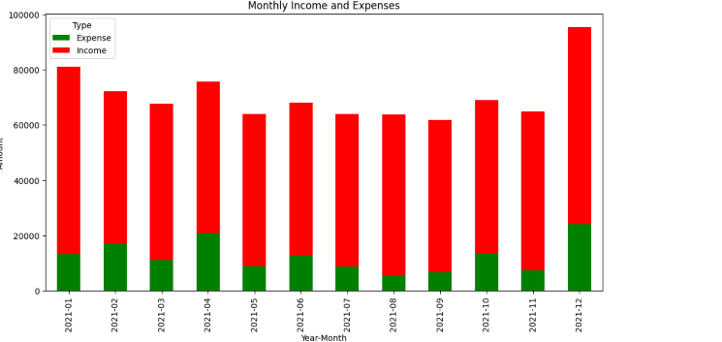

Figure 2: ARIMA Forecast of Monthly Expenses

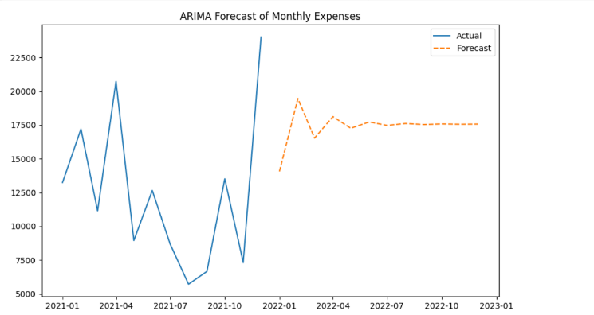

- Clustering Results

Clustering identified distinct spending behaviors:
- Cluster 1: High spenders with significant discretionary expenses.
- Cluster 2: Balanced spenders with proportional spending across necessities and luxuries.
- Cluster 3: Frugal spenders focusing on essential needs.
.
B. Expense Prediction

- ARIMA Model: Effective for users with consistent spending patterns, achieving MAE of 5-10%.

- LSTM Model: Outperformed ARIMA for users with fluctuating spending habits, reducing MAE to 3-8%.

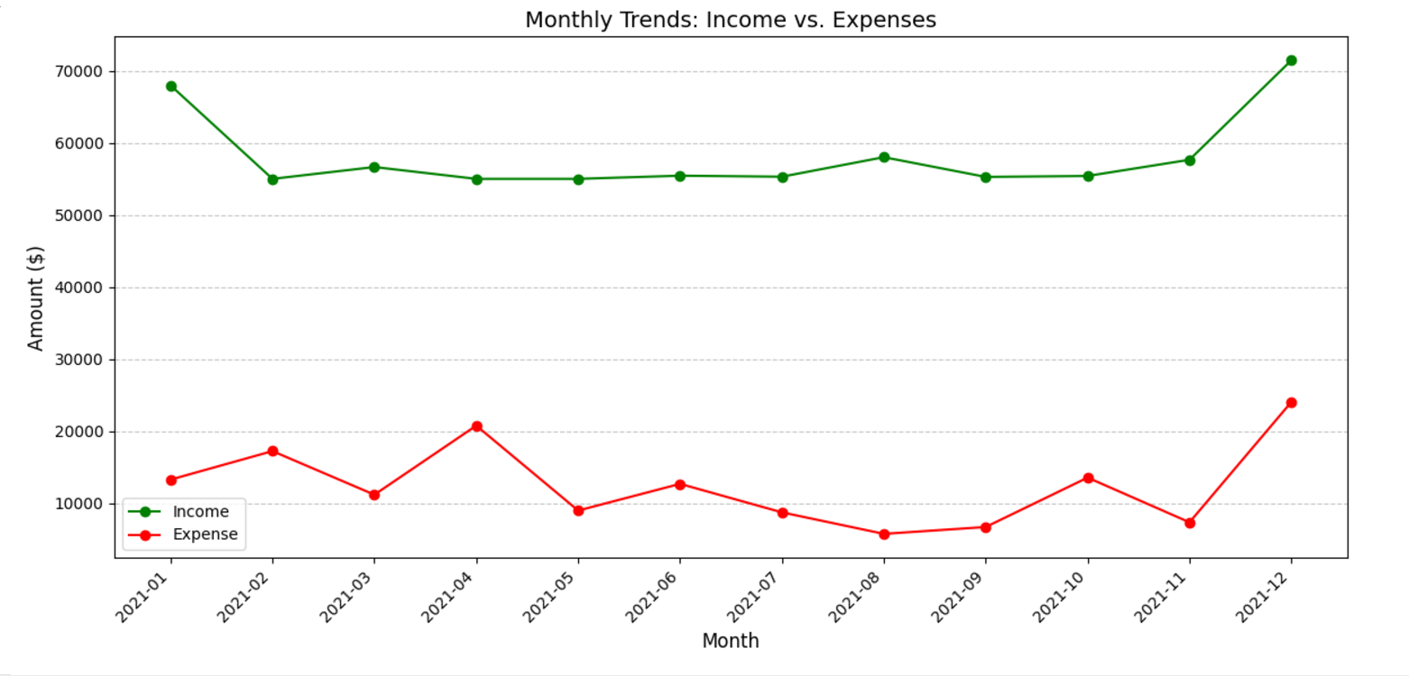

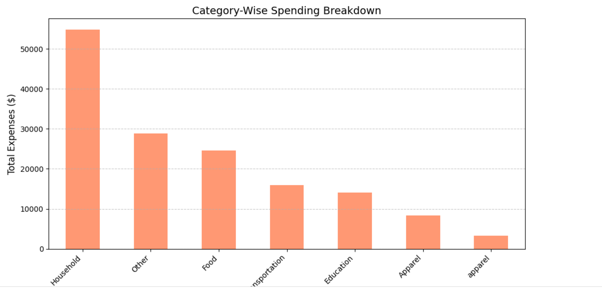

- Budget Plan Generation

  - Budgets were tailored to users' predicted expenses and income. Examples include:

- Setting savings goals at 20% of income for high spenders.
- Reallocating discretionary spending to essentials for low-income users.
- Creating emergency fund contributions based on surplus income.

- Visualization and Insights

Visual tools provided actionable insights, such as:

- Monthly overspending trends in specific categories.
- Income-to-expense ratio to guide financial adjustments.

VI. CONCLUSION

This study presents an integrated
Personal Finance Management System that combines expense analysis, predictive analytics, and dynamic budget planning. By leveraging clustering and time-series models, the system enables users to understand their spending habits, forecast expenses, and achieve financial stability. Future work could include real-time data integration with financial institutions and additional predictive features, such as investment planning.
VII. Future Scope

Future work could explore the integration of advanced machine learning models, such as neural networks, for more personalized predictions. Real-time financial data streaming from APIs could further enhance the system's responsiveness. Additionally, expanding the system to support multiple languages and currencies would increase accessibility for a global user base.

VIII. REFERENCES

- Kaggle Personal Finance Dataset. [URL of dataset]
- G. Box et al., "Time Series Analysis: Forecasting and Control," Wiley, 2015.
- D. Hochreiter and J. Schmidhuber, "LSTM Networks," Neural Computation, 1997.
- Seaborn and Matplotlib Libraries Documentation.

